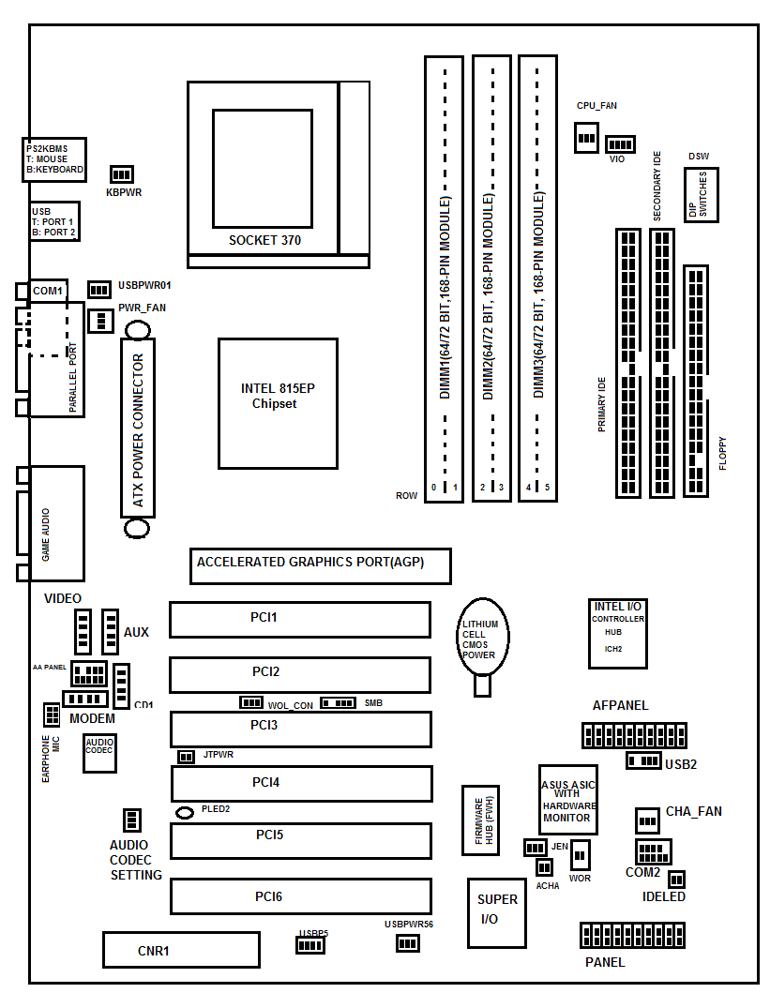
Asus Motherboard Layout
AGP(Accelerated Graphics Port) is a high-speed point to point channel for attaching a video card to computer's motherboard.
PCI(Peripheral Component Interconnector) a computer bus for attaching hardware devices in a computer. The PCI bus supports the functions found on a processor bus, but in a standardized format that is independent of any particular processor.
IDE(Intergrated Drive Electronics) is a standard electronic interface used between a computer motherboard's data paths or bus and the computer's disk storage devices.
CPU( Central processing unit) is the hardware within a computer system which carries out the instructions of a computer program by performing the basic arithmetical, logical, and input/output operations of the system.

